SPECIFICATION

DOCUMENT

Of

**LockedMe**

A Console Based Application

--------------------------------------------------------------------------------------------------------------------------------------

>>> Developer : SAI KRISHNA CHENNAKESAVULA

>>> Developer Email : [chsaikrishna6489@gmail.com](mailto:chsaikrishna6489@gmail.com)

>>> Designation : Full stack JAVA developer

>>> Company : Company Lockers Pvt. Ltd.

--------------------------------------------------------------------------------------------------------------------------------------

**INDEX**

**1 PROJECT DETAILS 3**

* 1. Developer Details
  2. Project Specifications
  3. Product Capabilities

**2 APPEARANACE AND USER INTERACTION 4**

**3 ALGORITHM OF APPLICATION 9**

**4 FLOW CHART 11**

**5 AGILE SCRUM FLOW 13**

5.1 Step By Step Processs

5.2   No: Of Sprints

5.3 Tasks Achieved

**6 GITHUB LINK 17**

**7 CORE CONCEPTS USED 17**

**8 CONCLUSION 17**

8.1 Conclusion On Enhancing The Application

8.2 Unique Selling Points

**DEVELOPER DETAILS:**

--------------------------------------------------------------------------------------------------------------------------

>>> Developer : Sai Krishna Chennakesavula

>>> Developer Email : [chsaikrishna6489@gmail.com](mailto:chsaikrishna6489@gmail.com)

>>> Designation : Full Stack Java Developer

>>> Company : Company Lockers Pvt. Ltd.

--------------------------------------------------------------------------------------------------------------------------

**PROJECT DETAILS:**

--------------------------------------------------------------------------------------------------------------------------

>>> Project Name : Lockedme

>>> Project Type : Console Based Application

>>> Project Concept : File Management System

>>> Language Used: JAVA 8

>>> Methodology Used : Agile Scrum

>>> Project Duration : 2 Weeks

>>> Project Started : 20-9-2020

>>> Project Submitted : 4-10-2020

>>> Software used : Eclipse

--------------------------------------------------------------------------------------------------------------------------

**PRODUCT’S CAPABILITIES:**

--------------------------------------------------------------------------------------------------------------------------

>>> To ADD A File To The Directory.

>>> To DELETE A File In The Directory.

>>> To SEARCH A File In The Directory.

>>> To Display All The Files In The Directory.

--------------------------------------------------------------------------------------------------------------------------

**APPEARANCE AND USER INTERACTION**

The flow of application is shown below:

**Step 1 :**  Below is the welcome page of the application

*********************************************************************************************************

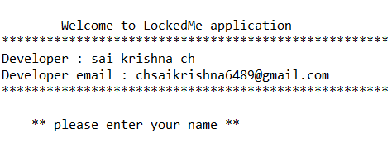

*********************************************************************************************************

**Step 2  :**  The application begins with the user entering his NAME,

Once the user entered the name, it will greet hello and then the application will display the below options for the user to interact :

1. View the files present
2. Operation Menu
3. Exit

It will ask the user to enter the appropriate choice(1-3)

*********************************************************************************************************

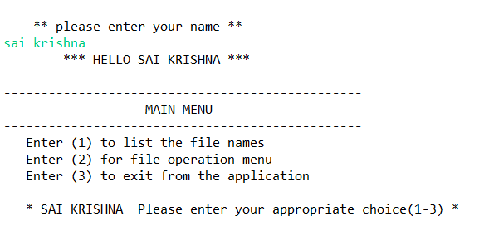

*********************************************************************************************************

**Step 3  :** if the user chooses the option 1 in main menu, then it will display list of files in the directory

*********************************************************************************************************

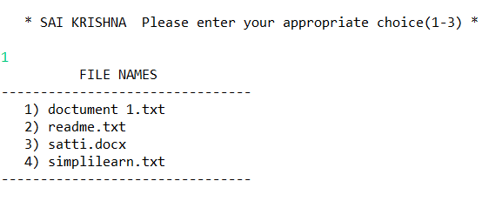

*********************************************************************************************************

**Step 4  :** if the user chooses the option 2 in main menu, then it will display the file operations menu as below for the user to interact :

1. Add a file
2. Delete a file
3. Search for a file
4. Go back to main menu

It will ask the user to enter the appropriate choice(1-3)

*********************************************************************************************************

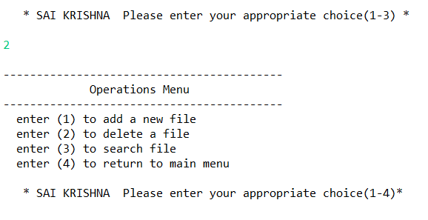

*********************************************************************************************************

**Step 5  :** if the user chooses the option 1 in operations menu, then the application will ask the user to enter the filename to add.

After the file name is entered, the application checks the directory for the file if it already exists it will prompt that the file already exists else it will create new file.

*********************************************************************************************************

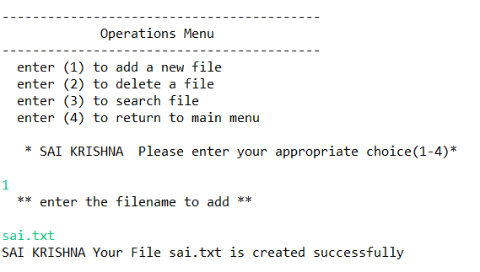

**If the file already exists then**

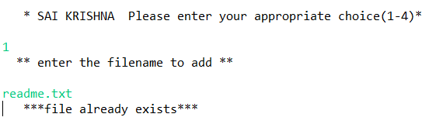

*********************************************************************************************************

**Step 6  :** if the user chooses the option 2 in operations menu, then the application will ask the user to enter the filename to delete.

After the file name is entered, the application checks the directory for the file if it exists it will prompt that the file deleted successfully else it will prompt file not found.

*********************************************************************************************************

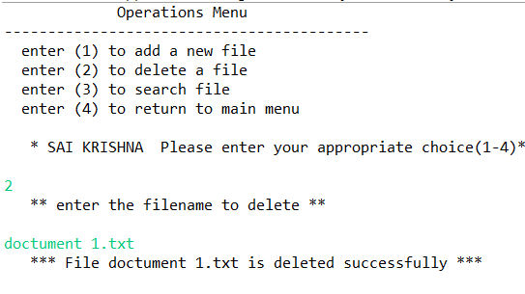

**If the file not present**

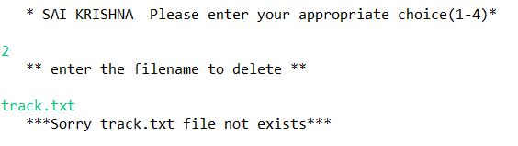

*********************************************************************************************************

**Step 7  :** if the user chooses the option 3 in operations menu, then the application will ask the user to enter the filename to search.

After the file name is entered, the application checks the directory for the file if it exists it will prompt that the file found else it will prompt file not found.

*********************************************************************************************************

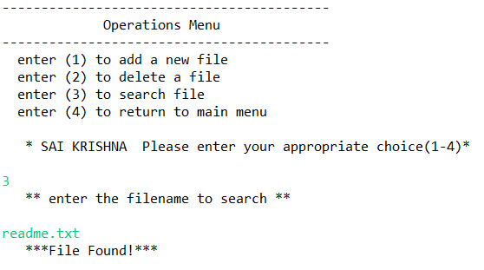

**If the file not present**

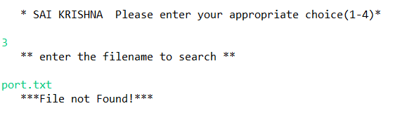

*********************************************************************************************************

**Step 8  :** if the user chooses the option 4 in operations menu, then the application will redirect to the main menu.

*********************************************************************************************************

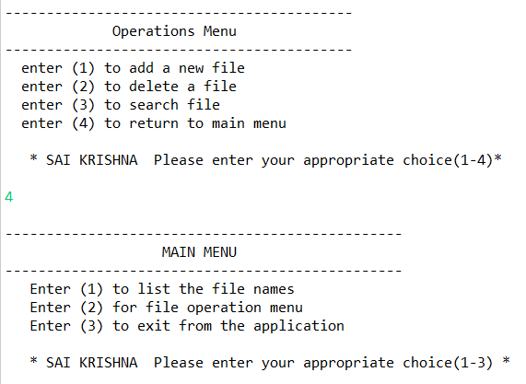

*********************************************************************************************************

**Step 9  :** if the user chooses the option 2, then it will display the file operations menu

*********************************************************************************************************

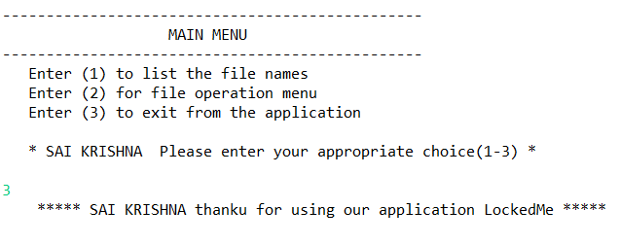

*********************************************************************************************************

**ALGORITHM OF APPLICATION**

Step-1: START

Step-2: DISPLAY welcome details

DISPLAY enter your name

ACCEPT name

Step-3: CREATE arraylist results

ADD all the filenames of files in the root directory to results list

Step-4: DISPLAY main menu

Step-5: DISPLAY input category

Step-6: ACCEPT category

Step-7: IF category = “1” then, GO TO Step - 9

IF category = “2” then, GO TO Step - 10

IF category = “3” then, GO TO Step - 18

Step-8: CASE: default

DISPLAY Wrong Choice... Please choose between 1-3 only

GO TO Step-3

Step-9:

Step-9.1: Sort the elements of the list results using collections.sort() method

Step-9.2: initialize variable i=0

Step-9.3: increment I by 1

Step-9.4: if I lessthan the length of results then GOTO Step ELSE Step-3

Step-9.5: DISPLAY results.get(i)

Step-9.6: GO TO Step:4

Step-10: DISPLAY operations menu

Step-11: DISPLAY input category

Step-12: ACCEPT category

Step-13: IF category = “1” then, GO TO Step -15

IF category = “2” then, GO TO Step -16

IF category = “3” then, GO TO Step -17

IF category = “4” then, GO TO Step - 4

Step-14: CASE: default

DISPLAY Wrong Choice... Please choose between 1-4 only

GO TO Step: 10

Step-15:

Step-15.1: DISPLAY enter the filename to add

Step-15.2: ACCEPT filename

Step-15.3: CHEAK if filename exists in results list

Step-15.4: IF filename exists DISPLAY *file already exists*

GO TO step:10

Step-15.5: IF filename not exists create the file with filename

DISPLAY * Your File filename is created successfully *

Step-15.6: GO TO Step:10

Step-16:

Step-16.1: DISPLAY enter the filename to delete

Step-16.2: ACCEPT filename

Step-16.3: CHEAK if filename exists in results list

Step-16.4: IF filename exists, DELETE the file filename

DISPLAY * File deleted successfully *

Step-16.5: IF filename not exists DISPLAY *Sorry file not exists*

Step-16.6: GO TO Step:10

Step-17:

Step-17.1: DISPLAY enter the filename to search

Step-17.2: ACCEPT filename

Step-17.3: CHEAK if filename exists in results list

Step-17.4: IF filename exists

DISPLAY * File Found *

Step-17.5: IF filename not exists DISPLAY * Sorry file not exists *

Step-17.6: GO TO Step:10

Step-18: DISPLAY thanku for using our application LockedMe

Step-19: STOP

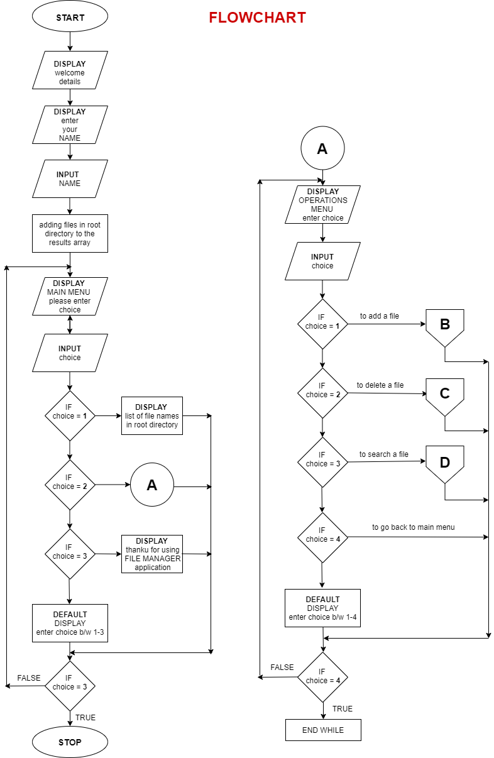

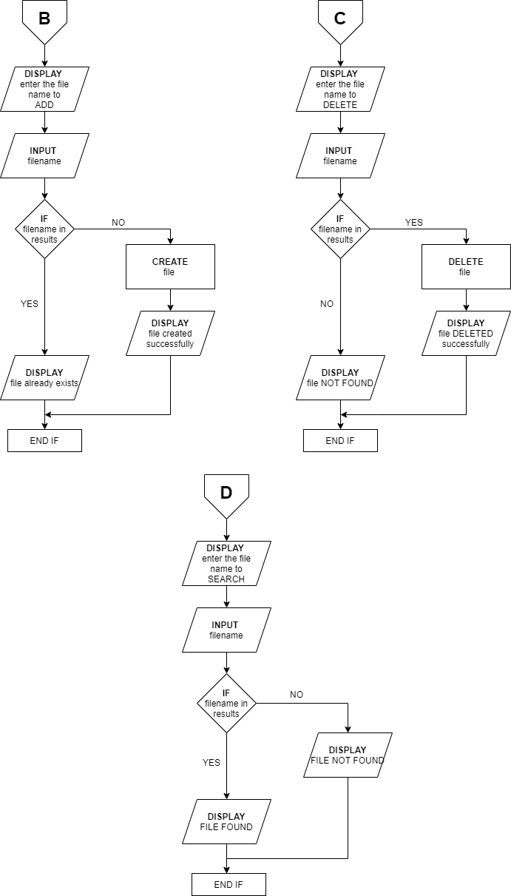

**AGILE SCRUM FLOW**

**Step-1:** started writing all user stories

Created 6 user stories

**Step-2:** made the estimation of all the user stories

Estimated for all the 6 user stories

**Step-3:** prioritised the user stories

**Title: delete file**

**Priority:** high

**size: 4**

**As a** *user*

**I want to** delete a specified file in directory

**so that I can** get rid of unwanted files

**Title: add file**

**Priority:** high

**size: 4**

**As a** user

**I want to** add a specified file to directory

**so that I can** store the file

**Title: display files**

**Priority:** high

**size: 5**

**As a** *user*

**I want to** display all files in directory

**so that I can** know which files are there

**Title: search file**

**Priority:** low

**size: 5**

**As a** *user*

**I want to** search specified file in directory

**so that I can** know that file exists or not

**Title: welcome screen**

**Priority:** low

**size: 2**

**As a** *user*

**I want to** display welcome screen when application started

**Title: menu**

**Priority:** high

**size: 6**

**As a** *user*

**I want to** display main menu and operations menu

**so that I can** easily navigate through

**Step-4:** selected the user stories and divided it into 9 tasks

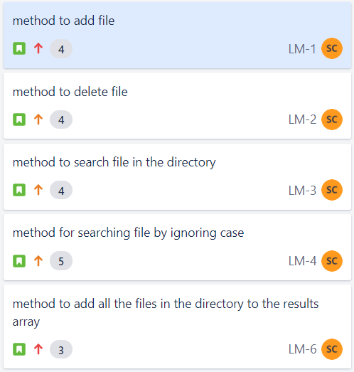 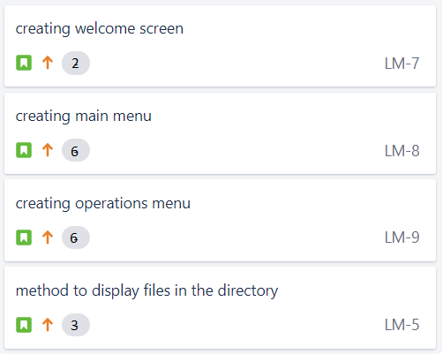

**Step-5:** created two sprints of each 1 week duration and allocated the

tasks to sprint1

**Step-6:** sprint1 started

In sprint1 we have 5 tasks

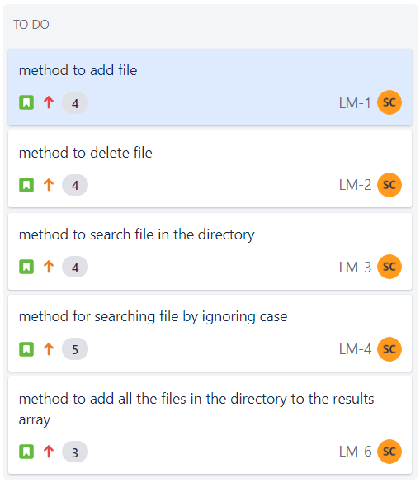

At the end of sprint, I had reviewed the sprint, I had completed 4 tasks and also tested and 5th task was in progress

So added 5th task to the sprint2

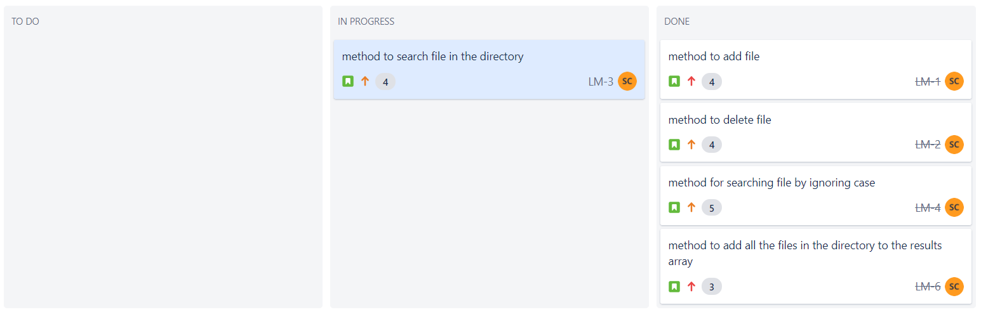

Here is my breakdown chart of sprint1

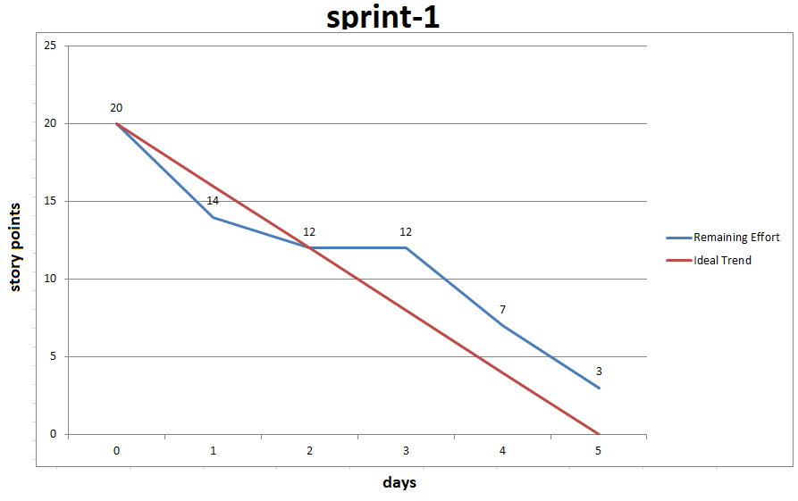

**Step-7:** sprint2 started

In sprint2 we have 4 tasks and 1task from sprint1 that is total 5tasks.

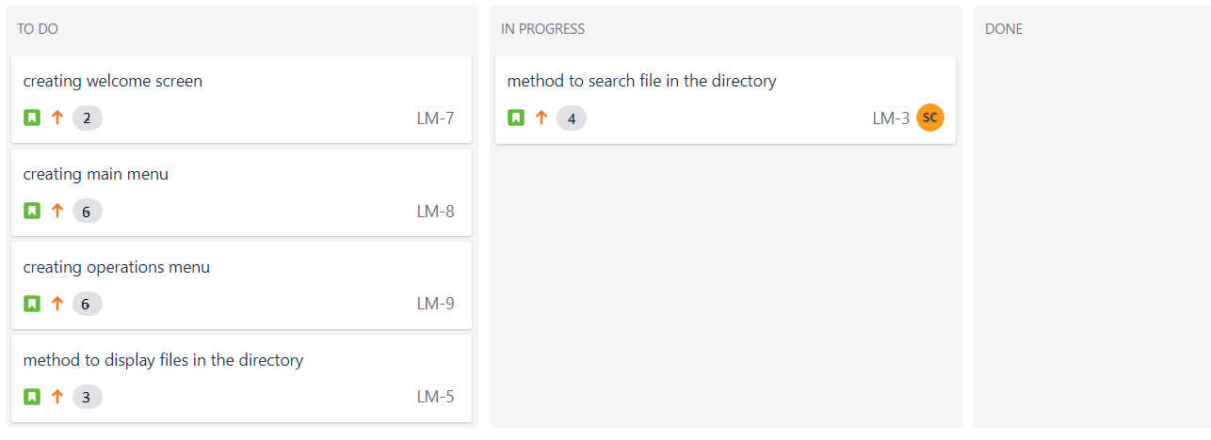

At the end of the sprint, I had reviewed the sprint, I had completed all the 5 tasks successfully and tested.

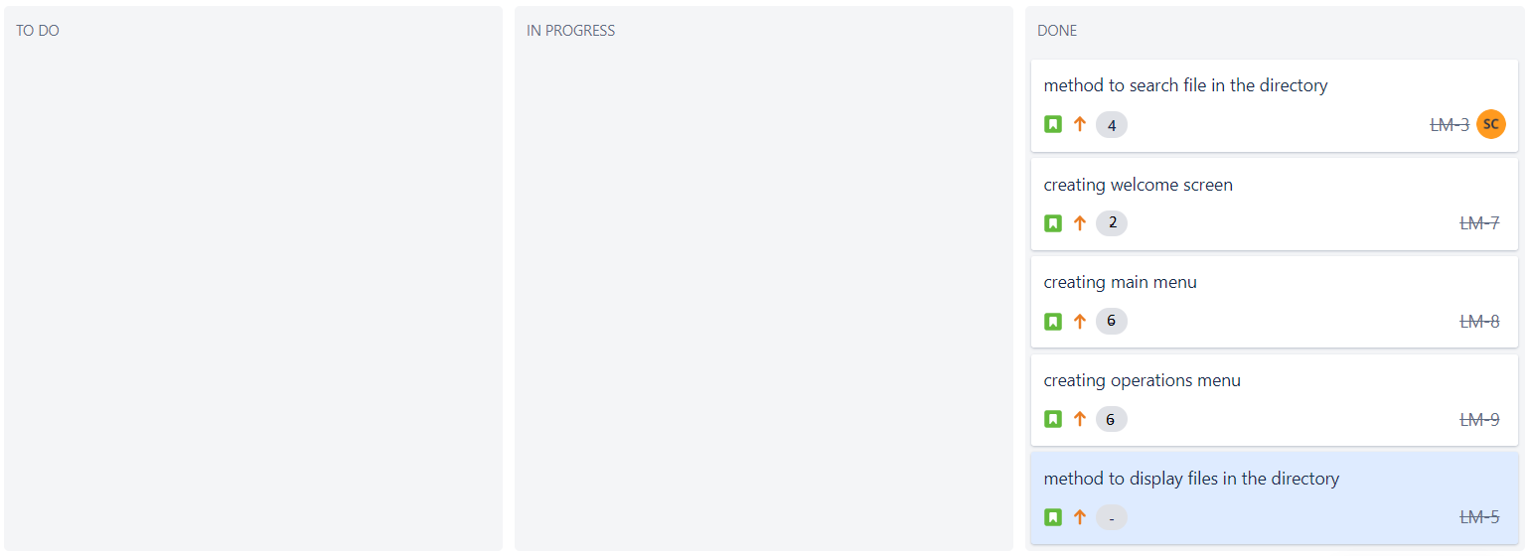

Here is my breakdown chart of sprint1

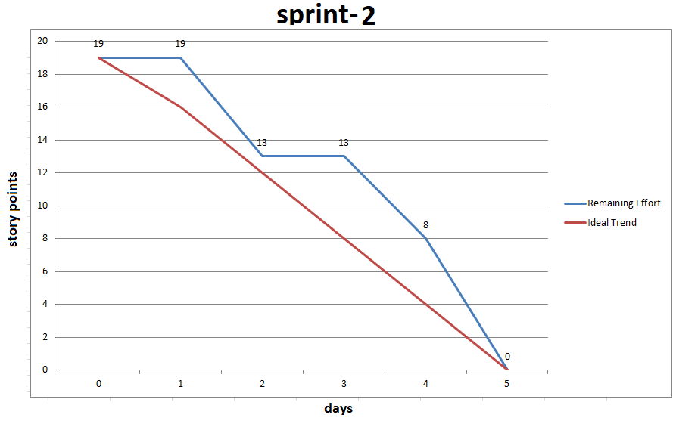

**Step-8:** the project is completed and tested finally released

**SPRINTS PLANNED:** 2

**TASKS ACHIEVED:** created methods to 1)create a file in the root directory

2) delete file in the root directory 3)search file in the root directory

4) display all the files in the directory 5) welcome screen

6) main menu 7)operations menu 8) search file in the root directory by ignoring case

9) to add all the files to the results array

**GITHUB LINK:**

https://github.com/saikrishna6489/simplephase1.git

**CORE CONCEPTS USED:**

ENCAPSULATION

EXCEPTION HANDLING

COLLECTIONS

COLLECTION METHODS

**CONCLUSION**

COCLUSION on enhancing the application:

We can display file size adjacent to the files when displaying files

We can add a facility to create user specified folders and store files in it

We can add a facility to delete multiple files at a time

We can also display the user logs

We can also create authorisation to access the application so that it becomes more

secure and safe

UNIQUE SELLING POINTS:

This application is simple to use

This application uses very less ram

This application works fast as it has low UI

And features like:

Adding files to the directory

Deleting files in the directory

Searching files in the directory

Display all the files in the directory